WHAT WE DO
We are in a highly competitive profession where the skills of our partners, legal associates and staffs determine our success. We are a people’s business, not only because our services are provided by people, but also because they are provided for people.
The ability to appreciate our clients’ needs and deliver services which meet and, where possible, exceed their expectations is vital for the continued strength of our profession. It is this ability which has built our reputation in the past, and which will continue to guide us in the future.
Our aim is not only to succeed, but to do so efficiently. We are client-focused problem solvers. We value smart, cost-effective legal strategies. We consult closely with clients before taking action and expending resources. We emphasize quality over quantity in staffing our projects and, when needed, can draw upon the expertise of our diverse practice groups to create flexible and effective interdisciplinary teams. Effectiveness, skill, creativity, dedication, tenacity, flexibility and pragmatism are our hallmarks. These are the qualities that have won us the trust of clients for fifteen years.

OUR PRACTICE AREAS

- Admiralty Law
- Alternate Dispute Resolution
- Banking & Finance Law
- Business Entity Formation
- Ship Collision Disputes
- Charter Party Hire, Freight/Dead Freight,
- Claim for loss/ Damage of Cargo/Shortfall
- Commercial Law
- Company Law
- Constitutional & Administrative Law
- Demurrage and Detention Claims
- Employment, Labor & Service Law
- Environmental Law
- Intellectual Property Law
- International Trade Law
- Investment Law (Domestic & International)
- Islamic Family Law
- Law and Development
- Legislation & Policy
- Maritime Dispute Resolution
- Non-Profit Organizations
- Real Estate & Property Law
- Securities Regulation
- Ship Arrest
- Taxation
- Telecommunications & IT law

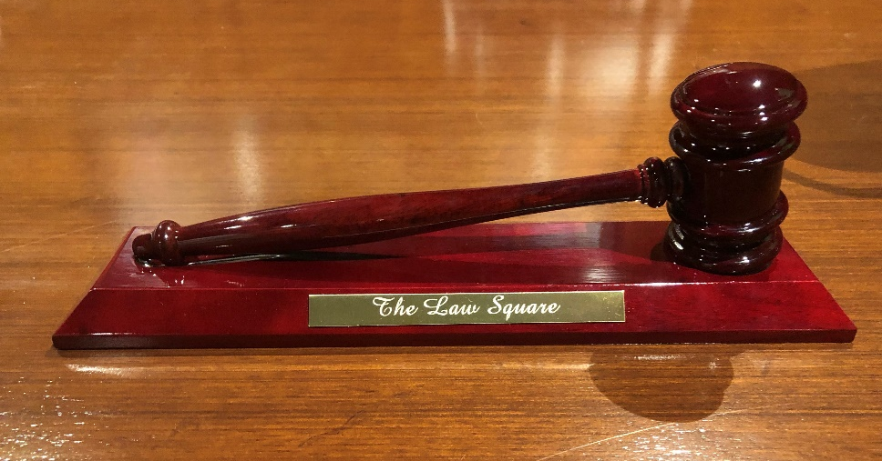

OUR BACKGROUND
The Law Square have a substantial and broadly based law practice, handling all aspects of business and corporate finance. Our lawyers operate with the commitment to make their client’s deals work. We provide a full range of legal services and we are skilled in using our expertise to pre-empt problems and construct business sensitive solution. We handle the shaping and implementation of all the different forms of transactions involved in modern business and finance.
The firm now consists of lawyers possessing diverse expertise in Banking & Finance, Telecommunication, Investment, Company Matters, Security Management, Risk Management and Litigation.

OUR QUALITY ASSURANCE
Our daily working practices center on a well-worked and refined methodology, designed to deliver and maintain professional standards. As a firm we recognize that despite our rigorous procedures, we cannot become complacent about the quality of our service and to that end we are now actively working towards working with our lawyers & staff to improve their quality. Our aim is to provide our clients and staff with a lasting confidence and belief in the capabilities of the firm and the manner in which we deliver our legal services.

ACHIEVING OPTIMUM VALUE OF OUR CLIENT
Cost awareness is very much a central element of our service ethos. In maximizing value for our clients, we focus on identifying the right solution to fulfill both the immediate and longer term objectives. When it comes to fees and billing, we are committed to being as open as possible, agreeing a comprehensive costing structure in advance, with regular financial statements to ensure that our clients are always aware of the costs incurred.

OUR INTEGRITY & EFFECTIVENESS
We believe that our future depends on maintaining the caliber, the experience and enthusiasm of our people and the integrity, effectiveness, sound judgments and discretion with which we conduct our client’s affairs.
The client has one partner and one legal associate as a ready point of contact through which his requirements can be managed, services coordinated, and quality assured. This partner consultant leads a selected team of lawyers, whose professional skills and experience meet the client’s needs.
OUR RESPONSE TO CHANGES
The world of business and finance changes rapidly. We are aware of the need to keep up to date with these changes and, whenever possible, to anticipate their effect. We know that we will continue to add significant value to our clients’ businesses only if we develop and adapt in the light of these changes.
OUR APPROACHES
We grasp the commercial consideration, which underlie transactions and the problems our clients bring to us. We regard it as important to understand fully the nature of each client’s business, the markets in which the clients operate and the real business issues involved in the matters we work on.
The lawyers in the firm aim to be positive and constructive. We use a flexible and commercial approach tailored to meet each client’ particular business needs. This gives rise to close working relationship between client and lawyer. The firm’s services are available from our office at Pioneer Road, the corporate and commercial heart of Dhaka City.

OUR GOALS
We grasp the commercial consideration, which underlie transactions and the problems our clients bring to us. We regard it as important to understand fully the nature of each client’s business, the markets in which the clients operate and the real business issues involve.
- To provide client oriented legal services to businesses, public and private sector organisations, entrepreneurial individuals and private individuals.
- To deliver legal solutions in a practical and efficient manner which combines flair, flexibility and integrity with a resolve to help our clients take full advantage of the opportunities within their business or personal environment.
- To encourage and maintain the loyalty of our clients through the implementation of customer care programmes and performance monitoring, using the results to introduce on-going improvements to our quality of service and methods of delivery.
- To develop an infrastructure and working environment which will attract, retain, develop and motivate high-caliber partners and staff, in a manner which is responsive to the welfare of each individual. We recognise that our quality of service is largely dependent upon the ability of our staff, and to this end the firm is committed to the implementation of programmes which encourage the development of skills and expertise in line with client needs.
- To maintain our commitment to investment in technology and systems which will enhance our service delivery and have a positive influence on quality, time and financial management, research and development and communications.

OUR PRO BONO
The provision of advice and support to those who need it the most, yet who are often least able to afford it, is at the very heart of the Law Square’s pro bono philosophy. We believe that we can use our legal expertise to ‘give something back’ to our local communities. We have a team of pro bono champions from around the firm who each manage pro bono activity in their region.
Under our firm’s wide pro bono scheme we provide free legal advice and representation to individuals and community groups who cannot pay and where public funding is not available. In addition, we support a number of community based schemes and initiatives that enable us to support hard to reach sections of the community. Our commitment earns us a place in the Legal Business Pro Bono Survey where we are ranked in the top 20 law firms in the country who spend the greatest number of hours working on pro bono activity.
Quite simply, our aim is to ensure access to justice for all.

APPROACH AND WORK PHILOSOPHY
At the Law Square, we are committed to providing legal services of the highest international standards. Our goal is to be the firm of choice for clients who value professionalism and commitment in addressing important legal challenges, disputes and commercial transactions.
Our lawyers believe in absolute commitment to the representation of our clients’ interests and take pride in their ability to effectively evaluate issues confronting our clients, and to communicate precisely on their behalf in any setting. Thorough research and preparation, honest, pragmatic advice and fluent advocacy based on an in-depth knowledge of the law are the hallmarks of the Law Square’s legal work.
Importantly, our lawyers are driven by the traditions handed down to them by their famous mentors in the legal profession – excellence, professionalism, tolerance, integrity and commitment to public service.

TEAM OF THE LAW SQUARE
HEAD OF CHAMBERS
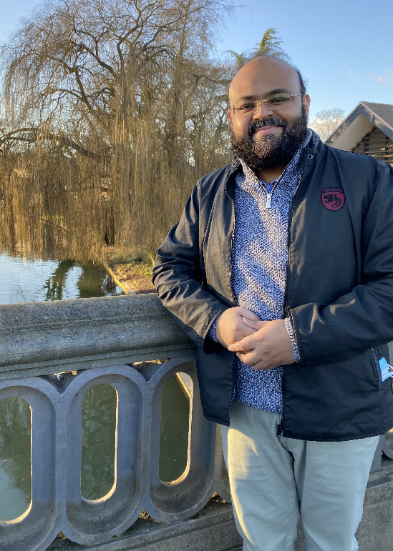

SAYED UL HAQUE
Barrister of Lincoln’s Inn

Phone: +880-1789-444-999
Email: headofchambers@thelawsquare.net
Website: www.thelawsquare.net
Location: The Law Square, Level-5, Nirman Samad Trade Centre, 63/1 Pioneer Road, Kakrail, Dhak-1000, Bangladesh

PROFESSIONAL EXPERIENCE

A dedicated lawyer and educator with substantial years of experience practicing commercially and voluntarily for the public interest, having proficient knowledge in criminal law, constitutional law, admiralty law, company law, and administrative law. A proven, experienced manager and effective team member; able to respond quickly and accurately to evolving laws and regulations. Adept with a wide variety of complex and sensitive cases; managed multiple teams and projects while maintaining a commitment to integrity. Solid interpersonal and communications skills in building key alliances and partnerships, having dealt with diverse clients and individuals. Highly organized & dedicated with a positive attitude, able to set practical priorities and handle multiple assignments under high pressure within tight deadlines.

EDUCATION

- Bachelor of Laws, University of Manchester. (2003).
- Bar Vocational Course, City University of London, UK. (2004)
- Post-Graduate Diploma in Professional and Legal Skills, City University of London, UK. (2004)
- Bar Vocational Course, Bangladesh Bar Council (2005)
- Advocate, Supreme Court of Bangladesh (2009)
- Undergraduate Accredited Course on Politics, University of Oxford, UK (2016)
- Master of Laws in Legal Practice, Nottingham-Trent University, UK. (2017)
- Post Graduate Certificate in Higher
Education, University of London, UK (2019)
- Master of Laws in IT & Telecommunications Law, University of Strathclyde, Glasgow, UK. (2021)
- Diploma in International Relations, University of Cambridge, UK. (2022)

BAR ADMISSIONS/AFFILIATIONS

- Supreme Court Bar Association, Bangladesh, 2009
- Dhaka Bar Association, Bangladesh, 2006
- Bangladesh Bar Council, 2005
- The Honourable Society of Lincoln’s Inn, UK, 2004
- Bar Council, UK, 2004.

VOLUNTARY AND COMMUNITY INVOLVEMENT
- Founder member of APON Foundation, launched in 2007, which provides mobile schools for street children.
- Delivered basic education to more than 600 children since inception, and in 2016, 86 students enrolled into formal schools through APON’s initiatives.
- Member of British School of Law Public Interest Law Clinic and engage in matters of social justice in particular for underprivileged communities.
- UN Online Volunteer – Supported identification of human rights recommendations from UN human rights mechanisms and special procedures addressed to Brazil, and related them to 17 Sustainable Development Goals.
- Student Legal Adviser 2001/2002 for Manchester Law School’s Legal Advice Centre
- Co-President of Bangladesh Student’s Association 2001-03

RESEARCH EXPERIENCES

- Conducted the research "Divestment of Government Funds from Tobacco
Industries Involved in Civil Society Organizations and Civil Groups" for
Bloomberg Philanthropies, USA and Campaign for Tobacco-Free Kids
(CTFK), Washington, USA.

- Conducted the research "Legal and Regulatory Review of Civil Registration and
Vital Statistics in Bangladesh" for Vital Strategies, New York, USA, and Global
Health Advocacy Incubator (GHAI), USA for reform of laws related to
CRVSID management of Bangladesh.

- The effect of the taxation regime/policies of Bangladesh on the
telecommunication sector as compared to other jurisdictions as India and the
US. (LLM in IT & Telecommunications Law research topic at University of
Strathclyde, Glasgow).

- Under sections 261 and 263 of the Companies Act 2006, whether a shareholder
will be given permission to continue a derivative claim now depends only on
whether a judge think continuing the claim will be in the company’s commercial
interests. Judges, however, are incapable of taking such commercial decisions
(LLM research topic at Nottingham-Trent University).

NEWSPAPER ARTICLES/OP-ED

Published articles can be found at
https://www.dhakatribune.com/author/sayed-ul-haque-dinar

CAREER HISTORY

- Advise individuals and commercial clients, and effectively lead and manage team of 12 staff to ensure delivery of a high quality, professional and ethical service.
- Practiced as advocate in Supreme Court, District and Sessions Courts and successfully conducted litigation in numerous high-profile cases.
- Appeared for the accused in criminal trials before Magistrate’s Courts, Sessions and High Courts in the appellate stage.
- Drafting various kinds of petitions (arising out of Artha Rin Mamla & other commercial matters) for High Court & Appellate Division of the Supreme Court of Bangladesh.
- Furnishing legal opinion with regard to day-to-day telecommunication business of Grameen Phone, company matters, banking business, enterprise, labor & service rules issues and international arbitration including Foreign Exchange Regulation, Letter of Credit etc.
- Drafting and vetting of various kinds of Deeds, Service Rules, Memorandum & Articles of Associations, Legal Notice, Plaints, Writ Petition, Affidavit-In-Opposition, Civil Revision Memorandum, Undertaking, Letter of Intent, Board Resolution, Memorandum of Understanding, Bank Guarantee, Corporate Guarantee, Letter of Comfort and other legal instruments.
- Interviewing and counseling clients.

NOTABLE CLIENTS:
International Organizations:
Bloomberg Philanthropies, USA. Campaign for Tobacco-Free Kids (CTFK), Washington, USA. Vital Strategies, New York, USA. Global Health Advocacy Incubator (GHAI), USA.
Government & Autonomous Authorities:
Dhaka Metropolitan Police; Titas Gas Transmission and Distribution Company Limited; Public Security Division of the Ministry of Home Affairs.
Companies and Banks:
Interport Ship Agents Limited, Interport Maritime Limited, Henderson Marine Bangladesh Ltd., Terranova Developments Ltd., Malik Seeds Ltd., Delta Socks Limited, Delta Dockyards Limited, etc.
Embassy:
German Embassy.

ADJUNCT FACULTY OF LAW

Jahangirnagar University: Adjunct Faculty, Department of Law and Justice,
Jahangirnagar University (2019-present).
The Equitas (Institute of British Law)- Haed of Laws. From 2004-present. University of London conferred the title “Worldwide Recognised Tutor” of University of London’s law courses in 2019.
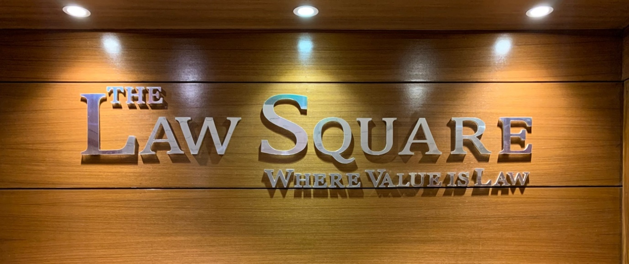

KEY TEAM MEMBERS
OF
THE LAW SQUARE

SENIOR ASSOCIATE
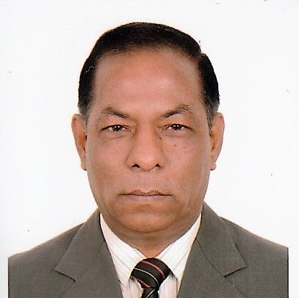

MUHAMMAD RUHUL QUDDUS

Phone: +88-01731-602-133
Email: mrquddusbd@gmail.com

PERSONAL STATEMENT

Law effects our everyday life & is an integral element of the society. My desire to study law is firmly rooted in my interest of helping others. I have studied many areas of the law and enriched me to serve the interest of the majority of the community.

I view law as a career in which I will have the opportunity to improve the life of others. I can work under tremendous pressure. I am committed to serve the under privileged people who don’t have access to justice due to their financial constraints. I am also committed to upheld Human Rights and Rule of Law in the Society.

EDUCATION

- LLB, University of London, UK
- LLB, National University, Bangladesh
- MPH in Health Management and Development, North South University, Bangladesh
- MPA in International Economic Relations, University of Dhaka, Bangladesh
- MA in History, University of Rajshahi, Bangladesh

WORK EXPERIENCE

- Senior Associate, The Law Square, Bangladesh, 2018-Present
- Civil Servant, Government of the People’s Republic of Bangladesh from 1988 - 2018;

Positions held:
- Additional Secretary
Ministry of Health and Family Welfare
- Director General
Health Services Division
- Joint Secretary
Ministry of Water Resources
- Deputy Secretary
Ministry of Expatriates’ Welfare & Overseas Employment
- First Secretary
Embassy of Bangladesh, Doha, Qatar
- Magistrate First Class

AREA OF SPECIALITY

- Civil Litigations
- Criminal Litigations
- Human Rights Law
- Commercial & Corporate Law
- Alternative Dispute Resolution
- Public Interest Litigation
- Judicial Review
- Administrative Law
- Employment and Labour Law

SENIOR ASSOCIATE
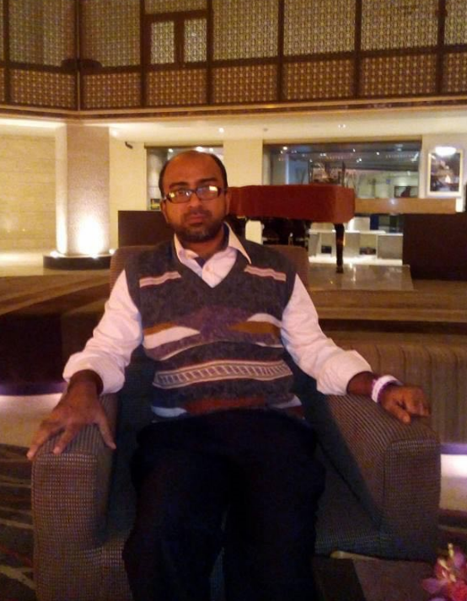

MD ABED HASAN BHUIYAN
Phone: +880-1823-209-370
Email: abed.hasan2309@gmail.com

PERSONAL STATEMENT

Law touches almost every aspect of our life and is constantly evolving to keep up with current society, to which we all belong.

While I was working at the beginning of my law profession, I came to understand the huge division between the rich and poor, and the injustice within the society that I live in. Working as a law associate has developed me on several ways. I have increased confidence, excellent communication skills and the ability to work under pressure.

Gradually over the last 6 years my responsibility has increased. I am currently a professional, having been selected by our head of chambers for additional responsibilities.

EDUCATION

- Advocate, Dhaka Judge Court, Dhaka, Bangladesh.
- LLB, University of London, UK
- MSS in Sociology, University of Dhaka, Bangladesh
- BSS (Hons) in Sociology, University of Dhaka, Bangladesh

WORK EXPERIENCE

- Senior Associate, The Law Square, Bangladesh, 2016-Present

AREA OF SPECIALTY

- Civil Law
- Law of Property
- Family Law
- Law of Succession
- Administrative Law
- Commercial Law
- Customs and Vat
- Employment and Labour Law

MEMBERSHIP & AFFILIATION

- Member, Dhaka Bar Association

SENIOR ASSOCIATE
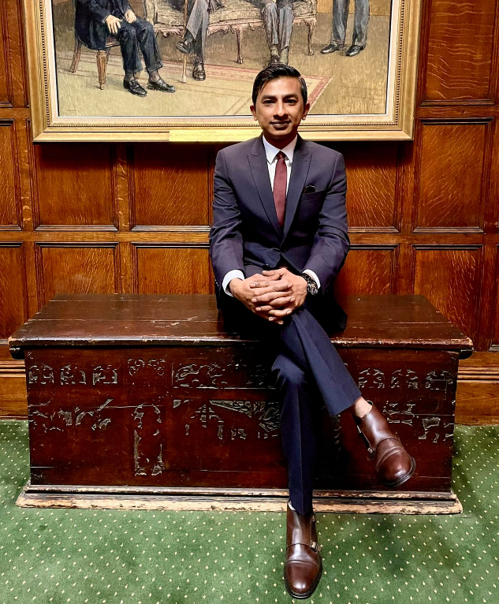

MD Khaled Siddiqui

Barrister of Middle Temple

Phone: +880-1309-264-026

Email: khaledsiddiqui29@gmail.com

PERSONAL STATEMENT

I find law immensely stimulating and its constantly changing nature provides a fascinating challenge to both society and those involved in the legal profession.

I have a strong will to learn the most advanced knowledge and skills in the world and to contribute my efforts to the further development of Bangladesh’s legal system. By pursuing this career, I am positioning myself to assist, define, mold and implement more universally accepted codes. While I don’t know how much difference I would be able to make in the future, I nonetheless feel an obligation to try. Being a law provincial, I can do better in the legal profession, can effectively dedicate my life to establish the rule of law of my country and also I have a vision to serve my community from a position of leadership.

EDUCATION

- Barrister of Middle Temple, UK
- BTC, University of the West of England, UK
- PGDL, University of the West of England, UK
- LLM, University of the West of England, UK
- LLB, University of London, UK
- Diploma-in-Law, University of London, UK

WORK EXPERIENCE

- Associate, Borhanuddin & Associates, Bangladesh, 2016-2018
- Senior Associate, The Law Square, Bangladesh, 2018-Present

AREA OF SPECIALTY

- Intellectual Property law
- Cyber Crime
- Civil Law
- Commercial Law
- Law of Property
- Family Law
- Administrative Law
- Admiralty Law
- Customs and Vat
- Employment and Labour Law

MEMBERSHIP & AFFILIATION

- Member, The Honourable Society of Middle Temple

ASSOCIATE
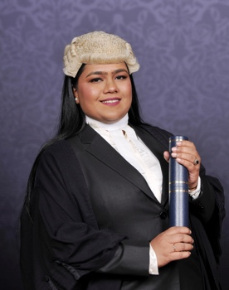

Tamanna Tarin
Barrister of Lincoln’s Inn

Phone: +880-1750-069-194

Email: tarintamanna123@gmail.com

PERSONAL STATEMENT

I am ordinary girl aspiring to become a good lawyer so that I can fight for the causes I believe in.

My interest in law stems from a fascination with resolving conflict and the important contribution it makes to our society. I find the Legal Arena very intriguing as it is so dynamic that in my day to day work life I have to face with numerous new challenges which prevents monotony from creeping in. I believe I have the tenacity to accomplish any task no matter how challenging that is.

I have always fancied litigating, which was the key impetus to train myself as a barrister. What beguiles me is how lawyers use interplay of wit, reason and legal paradigms to outwit others and change perceptions.

EDUCATION

- Barrister of Lincoln’s Inn, UK
- BPTC, City University, UK
- Master of Laws, City University, UK
- LLM in Maritime Law, BSMR Maritime University, Bangladesh
- LLB, University of London, UK

WORK EXPERIENCE

- Associate, The Law Square, Bangladesh, 2018-Present

AREA OF SPECIALTY

- Company Law
- Commercial Law
- Law of the Sea
- Maritime Law
- Family Law
- Custom & Vat
- Intellectual Property law
- Law of Property
- Administrative Law

MEMBERSHIP & AFFILIATION

- Member, The Honorable Society of Lincoln’s Inn, UK

ASSOCIATE

Irtiza Muhtasim Alim Niloy
Barrister of Lincoln’s Inn

Phone: +880-1711-335-841

Email: niloyalim@gmail.com

PERSONAL STATEMENT

I am conscientious team player with the ability to inspire my co-workers to greater productivity and cooperation. I enjoy learning, and am always able to taking on few challenges.

Laws makes a difference, and it is often the little things in law that make the big differences. This is what fascinates me about it. I found Law to be an extremely competitive and stimulating discipline that present many challenges; but I am enthralled by the opportunities that I may be confronted with overcoming those challenges.

Moreover, the competitive legal arena enhancing my employability prospects.

EDUCATION

- Barrister of Lincoln’s Inn, UK
- BPTC, City University, UK
- PGDL, City University, UK
- LLM, Queen Mary University, UK
- LLB, University of London, UK

WORK EXPERIENCE

- Associate, The Law Square, Bangladesh, 2019-Present

AREA OF SPECIALTY

- Civil Law
- Company Law
- Commercial Law
- Administrative Law
- Intellectual Property Law
- Admiralty Law
- Family Law
- Custom & Vat

MEMBERSHIP & AFFILIATION

- Member, The Honorable Society of Lincoln’s Inn, UK

ASSOCIATE

RAISA SAADIA
Barrister of Lincoln’s Inn

Phone: +880-1790-601-860

Email: raisa.saadia@gmail.com

PERSONAL STATEMENT

I am a new barrister, who has recently joined the team. I am very eager to learn and apply my knowledge for the development of the legal sector of Bangladesh. Choosing my career in law was a decision that changed my life for the better. I am determined to dedicate and work hard with sincerity, applying my skills and knowledge that I have gained till date, in order to make a positive change in the legal field of Bangladesh.

EDUCATION

- Barrister of Lincoln’s Inn, UK
- BPTC, University of the West of England, UK
- PGDL, University of the West of England, UK
- LLB, University of London, UK
- CHE in Common Law, University of London, UK

WORK EXPERIENCE

- Associate, The Law Square, Bangladesh, 2021-Present

AREA OF SPECIALTY

- Company Law
- Commercial Law
- Family Law
- Custom & Vat
- Intellectual Property Law

MEMBERSHIP & AFFILIATION

Member, The Honorable Society of Lincoln’s Inn, UK

Researchers
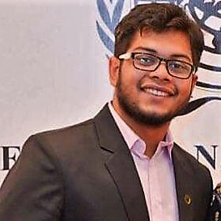  RAFIUL CHOWDHURY  Barrister of Lincoln’s Inn  BBA, LLB | 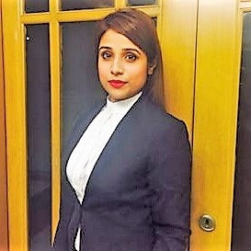  TASNOVA SALAM  LLB, BA (English Literature), MBA
TAZEEN NUWARI ANWAR  Barrister of Lincoln’s Inn  Accredited Commercial Mediator, LLB | TASNIN SIKDER  BA, LLB
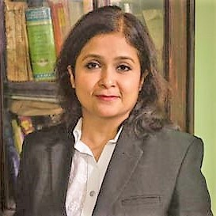

LAILA ARIYANI HOSSAIN
MA, LLB

Contact Information:

The Law Square,
Nirman Samad Trade Centre (4th Floor)
63/1 Pioneer Road, Kakrail, Dhaka-1000, Bangladesh.
Mobile: +88-01789-444-999, +99-01944-333-000
Email: Headofchambers@Thelawsquare.Net
Web: www.thelawsquare.net

